**The Land is So Rich in Beauty - Lv Shanchuan**

**Opening Reception: Thursday, 21 September, 6-8pm**

**Exhibition Duration: 21 September – 31 October 20173**

**G/F, 248 Hollywood Road, Sheung Wan, Hong Kong**

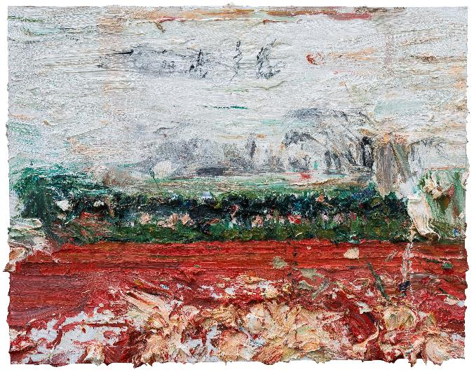

*The Land is So Rich in Beauty*, oil on canvas, 140 x 180 cm, 2017

(Hong Kong, September, 2017) Contemporary by Angela Li is proud to present “The Land is So Rich in Beauty”, Chinese artist Lv Shanchuan’s second solo exhibition in Hong Kong. This exhibition serves as a continuation of Lv’s first solo exhibition “Spectacle” in Hong Kong last year. While Lv’s creations are largely about social realism, they are also steeped in a liberal dejection within the context of Chinese contemporary art.

Dense dynamic crowds of people or brushstrokes show linguistic similarities, but the former are cohesive, centrist and incidental, while the latter are dispersive, isolated and scattered. The contradiction and opposition between the two even force the brushstrokes out of the painting. The artist has carefully preserved a pictorial overflow that seems to belong to the realm of form, semiconsciously producing a rest note of dejection.

**About the Artist**

Lv Shanchuan (b.1969, Fujian, China) graduated from the department of Fine Art at the Fujian Normal University in 1992 and completed his postgraduate studies at the Central Academy of Fine Art in 1997. He taught at the Fujian Normal University from 1992 to 2009, and went to Germany on the Sino-German Cultural Exchange Scholarship for further studies in 2005. He currently lives and works in Beijing.

Lv has held solo exhibitions and participated in group shows throughout China, Asia, Europe and the USA. Previous important exhibitions include: "*China 8 – Chinese Contemporary Art Exhibition*" (Germany, 2015), "*Epoch Writing: Chinese Contemporary Art Invitation Exhibition / The First Round*" (Epoch Art Museum, Wenzhou, 2015), "*The Unknown State*" (Beijing, 2015), "*Events* 2008 ― *with China*" (Today Art Museum, Beijing, 2014), "*The 9th Florence Biannual Exhibition* ― Ethics as the DNA of Art" (Italy, 2013), "*In Contemporary* ― *China Fine Arts Biannual Exhibition*" (Beijing, 2012), and "*The 8th Shanghai Biannual Exhibition*" (Shanghai, 2010). His works have been collected by the National Art Museum of China, Shanghai Museum of Art, Chengdu Museum of Contemporary Art, King Kuei Art Foundation and other international public institutions.

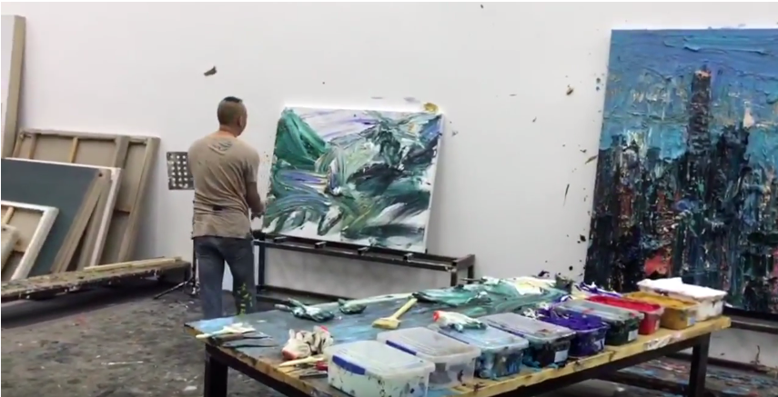

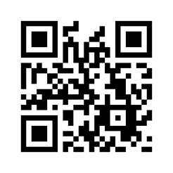  
Scan QR Code to watch Lv Shanchuan painting in his studio