Press Release | Hong Kong

Media Enquiry: Michelle Lau Contact: +852 3571 8200 Email: michelle@cbal.com.hk

**Cocoons – Peter Steinhauer Solo Exhibition**

**Opening Reception: 6 – 8 pm,**

G/F, 248 Hollywood Road, Sheung Wan, Hong Kong

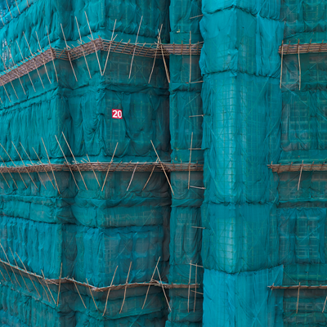

*Teal Cocoon – Hong Kong 2011*

Photograph

[Hong Kong, 2018] Contemporary by Angela Li is pleased to present San Francisco-based photographer Peter Steinhauer’s solo exhibition “Cocoons”, featuring a series of works that documents bamboo scaffoldings in Hong Kong. The exhibition also marks the release of his new book “Cocoons“, published by Powerhouse Books.

Upon Steinhauer’s first arrival in Hong Kong in the late 1990s, he was captivated by the sight of bamboo-caged buildings wrapped in fabric. He immediately thought these buildings were well-known environmental installation artist duo Christo and Jeanne Claude’s work of art. When Steinhauer later learnt it was an unique construction method of wrapping buildings in colourful mesh materials to prevent debris from falling onto the streets during renovation, he began his fascination with documenting Hong Kong cityscape from an unusual perspective.

The series name ‘Cocoons’ refers to the metamorphosis stage of the buildings, from caterpillar to butterfly, from architectural site to a brand-new building. For more than 9 years, Peter called Hong Kong home, he did not only focus on capturing the graphic nature of the intensely hued monolithic structures, he also captured time and place effortlessly. In his carefully framed photographs, the artist recorded the transformation of this restless city for over a decade as you see glimpses of the distinctive environmental surroundings of Hong Kong urban space.

Reproduced in this collectible book are 100 remarkable images that reflect Steinhauer's fascination with these hauntingly beautiful and monumental edifices, their bamboo scaffolding draped in brightly hued mesh material.

Steinhauer’s photography on Hong Kong has received numerous critical acclaims and recognitions. He received the prestigious **Lucie International Photography Awards** in 2014 and was selected as a finalist of the **“Photographer of the Year”** in the competition. He was also awarded the **PDN Annual Photographic Award of Excellence** for his *Cocoons* series in 2012.