Press Release | Hong Kong

Media Enquiry: Michelle Lau Contact: +852 3571 8200 Email: harriet@cbal.com.hk

**Wu Didi Solo Exhibition**

**Opening Reception: 6 – 8 pm, Thur 21 Mar 2019**

Address: G/F, 248 Hollywood Road, Sheung Wan, Hong Kong

Exhibition Duration: 22 Mar – 27 Apr 2019

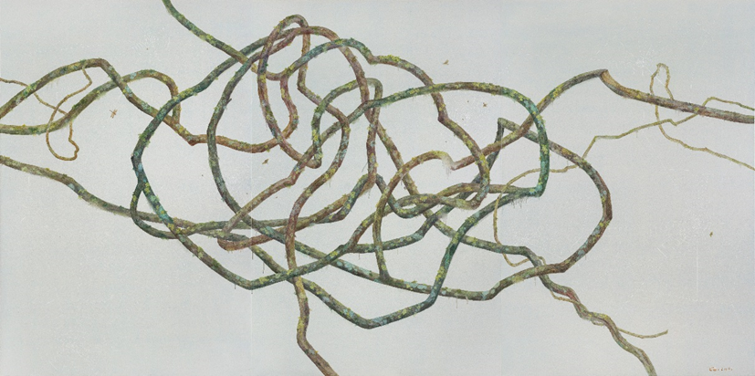

*Not Quite Empty No.10*, Oil on canvas, 210 x 420 cm, 2019

[Hong Kong, Mar 2019] Contemporary by Angela Li is pleased to present the second Hong Kong solo exhibition of Beijing-based artist Wu Didi. The exhibition features her latest oil paintings and mixed media works. Wu Didi describes the spirituality and immortality of nature’s simplest elements and reminds us of the meaning of their existence.

In most of her works, Wu Didi’s plants are directly suspended in front of the canvas in their purest sense of form. Their roots have been cut off. They do not, like the moss, grow in a specific and fitting environment. Animals and humans can move freely, their actions often concealed and feinted. Plants, on the other hand, do not move, they grow and expand slowly. What we see in the direct vision is a moment of the animal and the human, showing us the momentary fixation of space and force, but in the plant, we see the entire life, we see the extension of time and force. The spaces Wu creates instantaneously project a spectacular visual appearance, engaging the viewers to explore beyond the visual dimensions.

In *Not Quite Empty* series, the vines are the endless weaving of all manner of curved lines, with each vine line being a visible form of force, an expression and expansion of force. It has no direction, no foundation, no center, no goal. The dance of these vine lines on the canvas are like the dance of writing on the scroll paper.  These are trees and branches that have been cut off, trees and branches that have died, but the characteristic of branches is that they do not wither after death. After death, they retain astonishing vitality. The spider webs in between the vines reconstruct the lines of the composition, they are devised in order to allude to the invisible space. They act as a connector and constructor between the painting space and the visible subjects.

In *Still – Life Bamboo* series, the bamboos are “bended” into different geometrical shapes; the seemingly perfect re-creation of a bamboo shows unexpected breakage and distortions, revealing the inner character concealed by the external appearance. Interiority has been turned into externality, or, in other words, interiority and externality appear together in the same scene by way of distortion, representing bamboo’s qualities of resilience and toughness.

In *Moss Rock* series, the rocks symoblise stability and solidity, while the moss represents energy and vitality of every life form. The small and unnoticeable moss stubbornly grows and conquests the rock, showing its tenacity and vitality. Wu Didi considers all things equal and thinks each living being has its own uniqueness as a participant within the universe.

There are no impurities in Wu Didi’s paintings, no superfluous elements, no complex environments enveloping the plants, nothing polluting the plants at all, just the birds (or insects) flitting about amidst this purity, and they seem, as if infected by these plants, to have taken on the same extraordinary purity.

**About the artist**

Wu Didi (b.1976 in Chongqing, China) completed her postgraduate degree in oil painting at the Central Academy of Fine Art in 2004 and has been a lecturer at the Central Academy of Dramatic Art ever since. Her subject matters evolve from elements of traditional Chinese humanities. The artist had held solo exhibitions in Hong Kong, Beijing and New York, and her previous important exhibitions include “CHINA NOW” (London, 2016), “Beyond the Mirror Phase” (Era of Art Museum, Beijing, 2016), “Wu Didi” (New York, 2015) and “Temperature of History” (Shanghai Museum of Art, China, 2015). The artist currently lives and works in Beijing.

**About Contemporary by Angela Li**

Contemporary by Angela Li is dedicated to the promotion of contemporary and avant-garde artists from China, Hong Kong and worldwide. Since its establishment in 2008, the gallery has gained considerable attention and has become one of Hong Kong's top galleries for contemporary art. The gallery has held successful exhibitions for Chen Jiagang, Chen Wenling, Li Hongbo, Mo Yi, Tony Oursler, Georgia Russell, Shi Jindian, Peter Steinhauer, Martin Wehmer, Wong Hau Kwei, Nancy Chu Woo and Ye Funa, to name a few. In January 2013, the gallery moved to a bigger space at the trendiest part of Hollywood Road, with over 2,000 square feet of newly renovated exhibition space. The gallery's carefully curated exhibition programme consistently challenges and brings surprises to the local and international art scene.

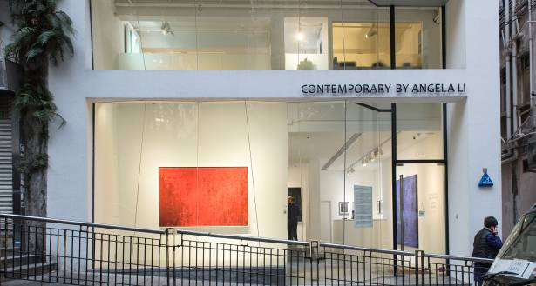

Gallery Exterior, Contemporary by Angela Li

Image: Courtesy of Contemporary by Angela Li

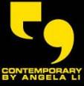**Contemporary by Angela Li**

Address : G/F, 248 Hollywood Road, Sheung Wan, Hong Kong  
Tel : +852 3571 8200  
Website : www.cbal.com.hk

Email : info@cbal.com.hk

Opening Hours : Mon – Sat 10.00 am – 6.30 pm

Sun & Public Holidays Closed